**Personal Health Tracker Application**

**Produced by: Derek Bixler,**

**Alec Dent,**

**Trenton Smith,**

**Tyler Wallace,**

**Mao Wen**

Use Case Diagram and Use Cases

for

Personal Health Tracker Application

**Produced by: Derek Bixler,**

**Alec Dent,**

**Trenton Smith,**

**Tyler Wallace,**

**Mao Wen**

February 21st, 2014

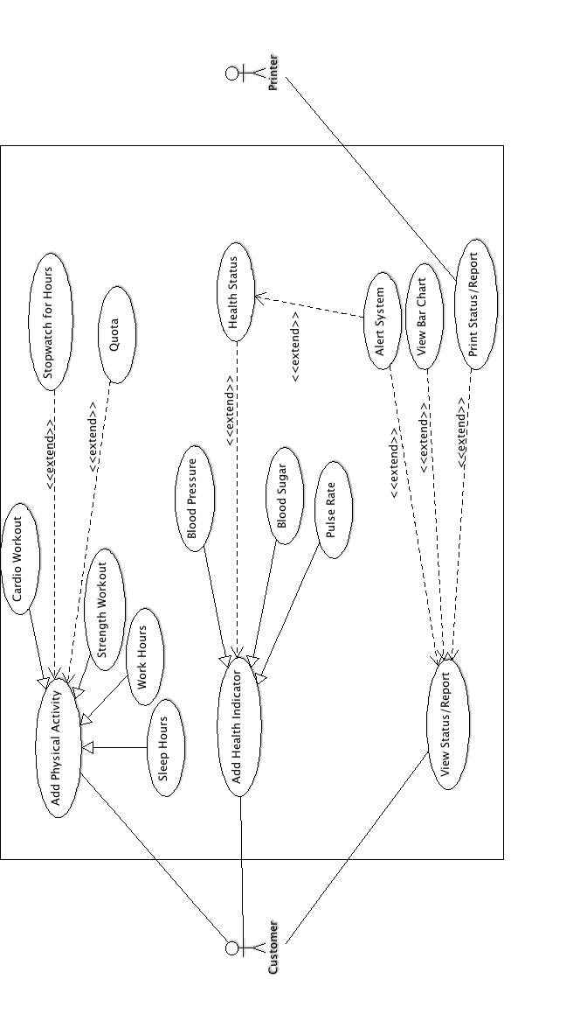

**Add Physical Activity:**

**Actors:** Customer

**Pre-conditions (Entry Conditions):**“Add Physical Activity” on main screen is clicked

**Post-conditions (Exit Conditions):**Message confirming the addition of the activity is displayed.

**Scenario:**The user runs the program from their computer. A graphical interface that lists the available options is displayed. The user clicks on the “Add Physical Activity” button. A new, smaller window is displayed with a dropdown menu that lists sleep, workout, and work hours. Below is a section that has two dropdown menus. One is for hours and the other is for minutes. Once the activity and duration of the activity have been selected, the user clicks on the OK button to confirm the addition of the activity.

**Exceptions:**

***Duplicate entry:***The addition of the activity will be denied.

***Daily total exceeds 24 hours:***The user will be asked to check their entry for errors or adjust the other activities already added.

**Use Case Relationships:** Extended function of Quota and Timer.

**Add Health Indicator:**

**Actors:** Customer

**Pre-conditions (Entry Conditions):**“Add Health Indicator” on main screen is clicked

**Post-conditions (Exit Conditions):**Message confirming the addition of the indicator is displayed.

**Scenario:**The user runs the program from their computer. A graphical interface that lists the available options is displayed. The user clicks on the “Add Health Indicator” button. A new, smaller window is displayed with three text input boxes for blood sugar level, heart rate, and blood pressure. Next to each input box is a check box. If the user checks the box, the input box next to it becomes active. It is possible to enter all three pieces of data at once. When the information that the user desires to be added, the user clicks on the OK button to confirm the addition of the indicator.

**Exceptions:**

***Duplicate entry:***The addition of the indicator will be denied.

***Entry contains extreme values:***The user will be asked to check their entry for correct values.

***Blank entry:***The user will be asked to check their entry for completeness.

**Use Case Relationships:** Extended function of Health Status

**Print Status/Report:**

**Actors:** User

**Pre-conditions (Entry Conditions):** “View Status” tab clicked.

**Post-conditions (Exit Conditions):** Document containing physical activities and health information has been printed.

**Scenario:** The user accesses the software on a personal computer and is shown the home screen where a physical activity and health indicator may be added. The user clicks on the “View Status/Report” button. Upon the button press, a new tab is displayed that shows an overall health indicator, and also graphs, bar charts, and text boxes detailing weekly and monthly status reports on physical activities and health indicators. The user clicks on the “Print Status/Report” button. A new window appears, displaying the graphs, bar charts, and text boxes in an orderly fashion. A dialog box is then displayed, querying the approval or denial of the printing job by the user. The user clicks “Yes” and approves the printing job. Upon approval, the user is brought back to the initial starting screen.

**Exceptions**:

**No physical/health information entered**: An error is shown to the student requesting the entry of either a physical activity or health indicator. Once information is input into either category, the user will be able to print a status report.

**Special Requirements (exceptions):** A printer must be installed. There must be information entered for physical activities or health information.

**Use Case Relationships:** extended function of “View Status/Report”, “Health Status”, “Quota”, “View Bar Chart”, and “Alert System”.

Software Requirements Specification

for

Personal Health Tracker

Version 1.0 approved

**Produced by: Derek Bixler,**

**Alec Dent,**

**Trenton Smith,**

**Tyler Wallace,**

**Mao Wen**

February 21st, 2014

Table of Contents

Table of Contents vii

Revision History vii

1. Introduction 1

1.1 Purpose 1

1.2 Project Scope 1

2. Overall Description 2

2.1 Product Perspective 2

2.2 Product Features 2

2.3 User Classes and Characteristics 3

2.4 Operating Environment 4

2.5 Design and Implementation Constraints 4

2.6 User Documentation 4

2.7 Assumption and Dependencies 5

3. System Features 5

3.1 Add Physical Activity 5

3.2 Add Health Indicator 6

3.3 View Health Status/Report 7

3.4 Stopwatch 7

3.5 Manage Quota 8

3.6 Generate Bar Chart 9

3.7 Print report/chart 9

4. Other Nonfunctional Requirements 10

4.1 Performance Requirements 10

4.2 Safety Requirements 10

4.3 Security Requirements 10

4.4 Software Quality Attributes 11

Revision History

|  |  |  |  |
| --- | --- | --- | --- |
| **Name** | **Date** | **Reason For Changes** | **Version** |
| Tyler Wallace | 2-20-14 | Initial input of team’s work | v. 1.0 |
|  |  |  |  |

# Introduction

## Purpose

The purpose of the Personal Health Tracker Application is to provide software that will allow a user to manage their health through the management of information of their activities and health status. The software will be easy to navigate and will provide the user with a user friendly interface to bubble up information they need/want to see such as notifying them of good health or the need to do more activity in order to fulfill a personal quota. It will also allow the user to generate reports based on their activity and will allow them to print a hard copy if desired.

## Project Scope

The user will open the software to see a general summary of their activity and health. After opening the software the user will have the option to add a physical activity, add a health indicator, to view a report/status, or to manage quotas. Adding a physical activity will prompt the user to enter the activity type and the amount of hours worked on that activity. Furthermore, the user can add any comments to the activity that can be viewed at a later date if desired or use a stopwatch function to time the activity and immediately have the hours logged. Adding a health indicator is similar to adding a physical activity in that the user will select the type of indicator: blood pressure, blood sugar, or heart rate and the current value of that. The user is suggested to do this on a daily basis in order to have the best data in the software. Selecting view report/status will give the user a window displaying average information from the database that the user will want to see, such as their average blood pressure, blood sugar, and heart rate. The user will have the ability to print the report if desired as well as the ability to create a bar chart from the data so that it is even more easily visible. Selecting manage quota will give the user a window that will allow them to set values as goals for each physical activity or health status. The software will then use this data when showing the report/status.

# Overall Description

## Product Perspective

The *Personal Health Tracker* project is a standalone software application intended for use on the Windows platform. It will be developed using C++ and an external library called ChartDirector, used to display graphs and charts. The application will allow users to insert, edit, and view data related to their health, such as various health indicators and the physical activities they take part in. All functionality related to the storing of the user’s data will take part within the user’s computer system.

## Product Features

**Core Features:**

1. Add Physical Activity
   * Allows user to enter information regarding the time they spent working, exercising, or sleeping
2. Edit/Delete Physical Activity
   * Allows user to make changes to any previous activities entered
   * User may delete any previous physical activity if needed
3. Add Health Indicator
   * Allows user to enter information regarding their blood sugar, heart rate, and blood pressure levels.
4. Edit/Delete Health Indicator
   * Allows user to make changes to any previous health indicators entered
   * User may delete any previous health indicator if needed
5. View Health Status/Report
   * Displays a summarized report of weekly/monthly physical activities and health information entered by user
   * Automatically updates each time user enters new information
6. Add Quota
   * Allows user to enter information regarding their health goals
7. Edit/Delete Quota
   * Allows user to make changes to their defined health quota
   * User may delete previous health quota if needed

**Additional Features:**

1. Print Health Status/Report
   * Allows user to print recent activities for personal or professional documentation
2. Alert System
   * Displays a color status of either green, yellow, or orange, based on the information users enter with respect to standard health recommendations
3. Stopwatch
   * Enables user to time physical activities such as time spent working, exercising, and sleeping

## User Classes and Characteristics

**Personal Health Tracker: Potential Scenarios**

1. Long-term health tracking (i.e. monthly-yearly tracking)
   * Key Functions:
     + Keep track of physical and health information, summarized monthly
     + Analyze user health information and deliver current status with respect to quota and standard health recommendations
     + Print health information in monthly increments
   * Requirements:
     + Simple method of displaying monthly health summaries, as opposed to weekly
2. Short-term health tracking (i.e. weekly-monthly tracking)
   * Key Functions:
     + Keep track of physical and health information, summarized weekly
     + Analyze user health information and deliver current status with respect to quota and standard health recommendations
     + Print health information in weekly increments
   * Requirements:
     + Simple method of displaying weekly health summaries, as opposed to monthly
3. Basic health tracking (i.e. daily health checks)
   * Key Functions:
     + Analyze user health information and deliver current status with respect to standard health recommendations
   * Requirements:
     + Simple method of viewing current health status

## Operating Environment

The *Personal Health Tracker* application will run on the Windows operating system using the .NET framework. The software will utilize a simple graphical user interface with basic elements such as charts and bar graphs, based on the C++ API and an external coding library named ChartDirector. The performance of the user’s computer will not be an issue, as the GUI and charts to be used are not hardware intensive. As such, there will be limited hardware constraints. The application will be self-contained, in that all data accessed and stored will be within the user’s personal computer system.

## Design and Implementation Constraints

Implementation of various graphing visuals will have to utilize external libraries, as C++ does not natively provide any. There may be difficulties in implementing an external graphing utility and displaying it properly within C++’s built in GUI libraries.

## User Documentation

The Personal Health Tracker application will feature a basic help menu. The help menu may be accessed at any time while the application is open. Within the menu, basic tutorials for each function of the software will be displayed to the user, such as showing how to add physical and health information, how to change their health quota, how to display weekly and monthly graph summaries, etc..

## Assumption and Dependencies

**Internal Dependencies:**

The implementation of the additional software features, including the stopwatch, print, and the alert system, will depend solely on the design of the core features. If the core features are implemented neatly and correctly, the additional features can be quickly added without hassle. If there are issues with the data, including how it is stored and how it interacts with other core features of the software (i.e. status with relation to quota and recommendations), then there will be difficulty when implementing the additional features.

**External Dependencies:**

**ChartDirector API:**

We will use the ChartDirector API in order to implement graphs to visualize the data tracked by the user.

Reference: http://www.advsofteng.com/

# System Features

## Add Physical Activity

3.1.1 Actors

User

3.1.2 Description and Priority

The user can add physical activities by selecting a specific activity type such as cardio workout, strength workout, sleep, and work and then input a certain amount of hours for those activities. This function has a high priority.

3.1.3 Stimulus Sequence

User has completed some physical activity and wishes to log it in the software.

3.1.4 Response Sequence

*The software is updated with the input information and a notification box is displayed to the user to inform them of the recent change.*

3.1.5 Functional Requirements

REQ-1: *Selection of activity type: work, sleep, strength workout, and cardio workout.*

REQ-2: *Enter the hours in for the activity*

## Add Health Indicator

3.2.1 Actors

User

3.2.2 Description and Priority

The user can specific health information that can be measured by the user at their home. This includes: blood sugar, heart rate, and blood pressure. This feature is of high priority.

3.2.3 Stimulus Sequence

User should input information on a daily basis.

3.2.4 Response Sequence

*The software is updated with the input information and a notification box is displayed to the user to inform them of the recent change.*

3.2.5 Functional Requirements

REQ-1: *Selection of health type: blood sugar, heart rate, or blood pressure.*

REQ-2: *Enter the value of the type.*

## View Health Status/Report

3.3.1 Actors

User, Printer

3.3.2 Description and Priority

The use can view their health status or generate a report. In this status/report the general information about the user will be given as well as their average for their blood pressure, blood sugar, and heart rate. There will also be weekly averages for the user’s activity, such as a weekly average for the amount of strength workouts done. The user if desired can also print the report.

3.3.3 Stimulus Sequence

User desires to track progress of activities and see how healthy they are becoming.

3.3.4 Response Sequence

*The software displays the desired information in a pop-up window in which the information will be displayed in an organized fashion to the user.*

3.3.5 Functional Requirements

REQ-1: *Needs data in the system in order to generate a report.*

REQ-2: *User has a printer available to print the report.*

## Stopwatch

3.4.1 Actors

User

3.4.2 Description and Priority

Allows the user to time their activity using a stopwatch function on the software itself. The software will immediately calculate the allotted hours for the activity based upon the time spent and enter it in for the user.

3.4.3 Stimulus Sequence

User wants to add a physical activity which they are going to do at that moment, they can then time the activity using the stopwatch feature.

3.4.4 Response Sequence

*The software is updated with the information from the stopwatch and the update it visible to the user and awaiting their response to create the activity.*

3.4.5 Functional Requirements

REQ-1: *User is going to complete the activity right after selecting adding the activity.*

## Manage Quota

3.5.1 Actors

User

3.5.2 Description and Priority

The user can add a desired amount of hours for each activity as well as the desired health status in the quota management section. The software will use this data against the data input by the user for their activities completed.

3.5.3 Stimulus Sequence

User wants to set a goal for amount of hours done for each activity.

3.5.4 Response Sequence

*The software notifies the user that the data has been entered and will now track the progress of the user as they input data in for their activities.*

3.5.5 Functional Requirements

REQ-1: *Goal must be the correct type, i.e. for blood pressure cannot just put 120 must be 120/80.*

## Generate Bar Chart

3.6.1 Actors

User

3.6.2 Description and Priority

The user can prompt the software to generate an easily readable bar chart for the health report so that information on what the user has been doing for the week/month is there. The user then has the option to print the chart, save the chart, or to simply exit.

3.6.3 Stimulus Sequence

User wants to see their progress over the past week or month.

3.6.4 Response Sequence

*The software creates a bar chart for the user to see with labeled axes and visible quantities.*

3.6.5 Functional Requirements

REQ-1: *Data is required in the software.*

REQ-2: *Printer is needed in order to print*

## Print report/chart

3.7.1 Actors

User, Printer

3.7.2 Description and Priority

The user can print their report or chart from the software.

3.7.3 Stimulus Sequence

User desires to have a hard copy of the report from the software.

3.7.4 Response Sequence

*The software connects with the printer and tells the printer to generate a report.*

3.7.5 Functional Requirements

REQ-1: *Must have already viewed/generated a report or bar chart.*

REQ-2: *User must have a printer available and connected.*

# Other Nonfunctional Requirements

## Performance Requirements

Performance will be a non-issue within the Personal Health Tracker application. It will use basic GUI and graphing utilities, as well as simple data handling and storage within the user’s computer, all of which require very little computation time.

## Safety Requirements

The Personal Health Tracker application will handle data and memory correctly and efficiently, so as to not put a burden on other aspects of the user’s computer. The software should not be used to diagnose any health related issues based on the health recommendations it provides.

## Security Requirements

The Personal Health Tracker application will handle all data within the user’s computer using files that are saved locally. The only person with access to the health information saved will be the user of the software application. They may print their information to bring to a health professional or make public if they choose to do so.

## Software Quality Attributes

The graphical user interface of the application will be designed to be easy to read and interpret, displaying only the features that are needed to function efficiently. Graphs and bar charts will display according to the usage requirements of the user (daily, weekly, and monthly summaries). Printing features will be based on the amount of data the user has entered, extending to weekly, monthly and yearly printing summaries. Alerts will adapt based on health quotas to be entered by the user. The application will run on any computer, so long as the application and its files are moved together.

Users Guide

for

Personal Health Tracker

Version 1.0 approved

**Produced by: Derek Bixler,**

**Alec Dent,**

**Trenton Smith,**

**Tyler Wallace,**

**Mao Wen**

February 21st, 2014

Overview of User Interface

When the user first runs the program they are greeted with the main window where they are able to select or add user profiles and quickly view their progress for the week. At the bottom of this window there are three buttons. These three buttons open sub-windows that let the user add daily activities, current health indicators, and view or print a detailed report of their progress. The rest of the content in this guide shows an image of each window and provides detailed descriptions of their functionality.

Screen Images

On the main window, shown in figure 1, there is no menu bar as all functions are accessible from the main window. From here the user is able to select from a list of user profiles or create a new one. Also, they are able to quickly view their health status and weekly quota. To access other functions of the program there are three buttons on the bottom pane that allow the user to input their daily activities, health indicators, and view a detailed report. If any of these buttons are clicked, a sub-window pops up for the user to access other program features.

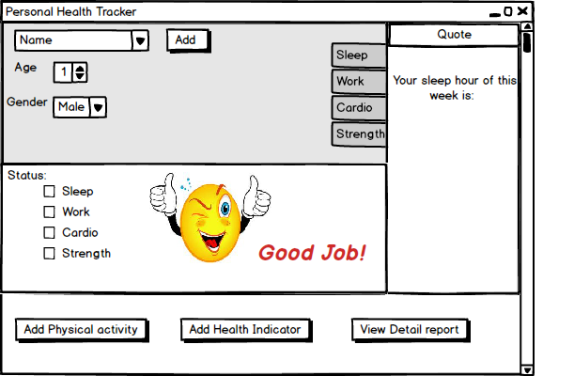

figure 1

When the “Add Physical Activity” button is pressed, it’s corresponding window (shown in figure 2) is displayed to the user. Here the user can select an activity type from a drop-down menu and input the time they spent doing that activity. Additionally, the user can input any notes or memos for the activity for future reference. Once the information has been entered, the user can add the activity to their record with the “Add” button. If at any time the user wishes to cancel the addition of a physical activity, the may do so by clicking the “Cancel” button.

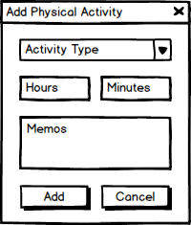

figure 2

When the “Add Health Indicator” button is pressed, it’s corresponding window (shown in figure 3) is displayed to the user. The functionality is similar to the “Add Physical Activity” window. However, the user will instead choose the health indicator to add as well as it’s associated measurement.

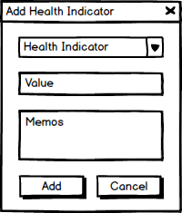

figure 3

When the “Detailed Reports” button is pressed, it’s corresponding window (shown in figure 4) is displayed to the user. Here the user can see graphs of their weekly, monthly, yearly, and all-time progress. In the top left of the window the user is able to select the length of time the graph will plot. The averages section to the right of the graph displays the averages for all possible entries. These are weekly, monthly, yearly, or all-time averages depending on which tab is selected above the graph. The user may write any notes in the notes section before printing the report, should they desire to. The report is printed on a single page and contains the graphs, averages, and notes for all four time-divisions.

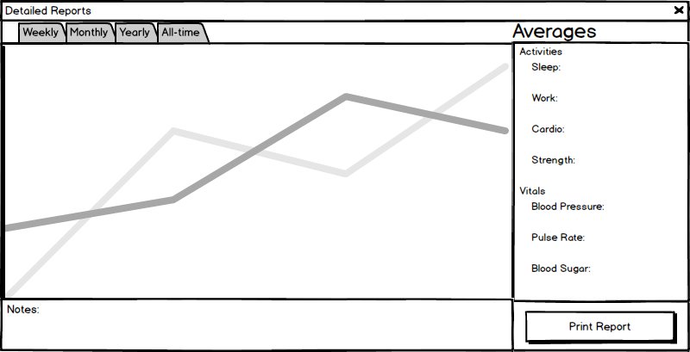

figure 4

|  |  |  |  |  |  |
| --- | --- | --- | --- | --- | --- |
|  | Derek Bixler | Alec Dent | Trenton Smith | Mao Wen | Tyler Wallace |
| Cover page |  |  |  |  | 100% |
| Use case diagram | 20% | 20% | 20% | 20% | 20% |
| SRS | 10% | 35% | 10% | 10% | 35% |
| User’s Guide | 37% | 8% | 8% | 37% | 10% |
| Credit sheet | 20% | 20% | 20% | 20% | 20% |
| Table content |  |  |  |  | 100% |
|  |  |  |  |  |  |

**Credit Sheet**

Activity

Team Member contribution

**Extra Credit Proposals**

|  |  |  |
| --- | --- | --- |
| **Extra feature** | **Proposed extra credit%** | **Accepted/Rejected (by instructor)** |
| GUI Interface | 6% |  |
| Quota & Alert System | 2% |  |
| Bar chart visual | 2% |  |